Original Code gave the error in the following:

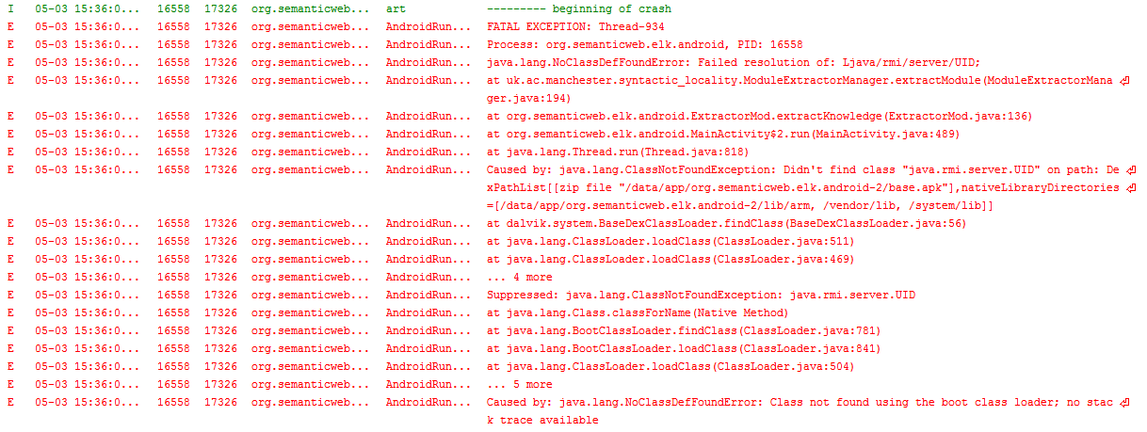

I have observed that Android environment doesn’t support “java.rmi.server.UID” class.

This class was just used in saving new module for giving an identical name as in:

**return** getLocalityModuleForSignatureGroup(signature, "http://krono.ac.uji.es/Links/ontologies/module" + **new** UID()+ ".owl");

I changed it to:

String dUID = String.*valueOf*(System.*nanoTime*()); // new UID()

**return** getLocalityModuleForSignatureGroup(signature, "http://krono.ac.uji.es/Links/ontologies/module_" + dUID + ".owl");

By this way, an identical name is provided for a new module not by “java.rmi.server.UID” class but System.*nanoTime*())